BEENEUM MUIGAI
Global Superstore Power BI Project
Part 1: Business Understanding
What is Business Intelligence?
Business Intelligence (BI) is basically about taking raw business data and turning it into information people can actually use. It covers collecting the data, cleaning it up, analyzing it and presenting it so an organisation can see how it is doing and make better decisions.
For this project I used Power BI to look at Global Superstore's sales data. I took the transaction records and built an interactive dashboard showing sales, profit, customer segments, product performance and regional performance.
Why do organizations use dashboards?
Dashboards put the important information in one place. Nobody wants to scroll through thousands of transaction records, so managers can check the key figures, compare performance and spot problem areas quickly.
For a retail business, a dashboard can show whether sales are growing, which products make the most profit and which regions bring in the most revenue. It also means different departments are all working from the same numbers.
How do dashboards improve decision-making?
They make performance much easier to understand. Charts show trends and differences, and KPI cards give a quick overview of the main results.
The filters also let managers dig into specific areas. In my dashboard, users can filter by Year, Market and Category to see how the results change. This leads to more focused decisions instead of relying on overall totals.
Dashboards also help separate sales from profitability. A category can have high sales but keep very little profit, so showing both measures helps management see where to look more closely.
What is the business objective of the selected dataset?
My objective was to find the biggest contributors to business performance, highlight areas with weak profitability and suggest practical actions for profitable growth.
I designed the dashboard around three main questions: where the revenue comes from, how much profit it produces and which areas need attention.

Part 2: Data Preparation
How did I import the dataset?
I imported the Global Superstore CSV file into Power BI using the Text/CSV connector. Before loading it, I clicked Transform Data so I could check and prepare everything in Power Query first.
What does the dataset represent?
It contains retail order lines. Each row is a product within an order, not necessarily a whole order.
It includes order and shipping dates, customer details, locations, product information, sales, quantities, discounts, profit and shipping costs.
What was the structure of the dataset?
The dataset had 51,290 rows and 24 columns. These included identifiers like Row ID, Order ID, Customer ID and Product ID, plus descriptive fields and numerical measures.
Row ID identifies each individual record. Order ID can appear more than once because a customer can buy several products in the same order.
How did I check for missing values?
I used Power Query's column quality and column profiling tools to check the whole dataset for empty values and errors.
Postal Code had 41,296 missing values. I decided to keep these records because the other fields were still useful, and Country, State and City were available for the geographic comparisons.
How did I handle duplicate records?
I checked for exact duplicate rows across all columns and found none, so the dataset stayed at 51,290 rows.
I did not remove repeated Order IDs, since multiple products can belong to the same order.
How did I correct inappropriate data types?
I changed Order Date and Ship Date from text to Date. I used the English (United Kingdom) locale so the day-month-year format was read correctly.
Identifiers and descriptive fields were set as text. Row ID and Quantity became whole numbers, while Sales, Profit and Shipping Cost became decimal numbers. Discount was set as a percentage.
What other cleaning decisions did I make?
I kept the negative profit values because they represent losses, not data errors. I also kept the missing postal codes rather than deleting transactions that were otherwise useful.
Overall, the preparation was about making the data suitable for accurate calculations, filtering and trend analysis.

Part 3: Dashboard Development
KPIs
Total Sales
I summed the Sales column, which gives total sales of 12.64 million. The Sales column already shows the amount for each order line, so I didn't multiply it by Quantity.
Total Profit
I summed the Profit column. The dashboard shows total profit of about 1.47 million.
Total Orders
I used a distinct count of Order ID so orders with several products weren't counted more than once. The dashboard shows about 25.03 thousand orders.
Average Sales
I took the average of the Sales column, which came to 246.49 per order line. This is the average sales per record, not the average order value.
Profit Margin
I divided Total Profit by Total Sales and formatted it as a percentage. The overall profit margin was 11.61%, which means the business made roughly 11.61 in profit for every 100 in sales.
Visualizations
I used eight visuals: Sales and Profit by Region, Total Sales by Category, Top 10 Products by Profit, Profit by Sub-Category, Monthly Sales Trend, Total Sales by Segment, Top 10 Countries by Sales and a Product Performance matrix.
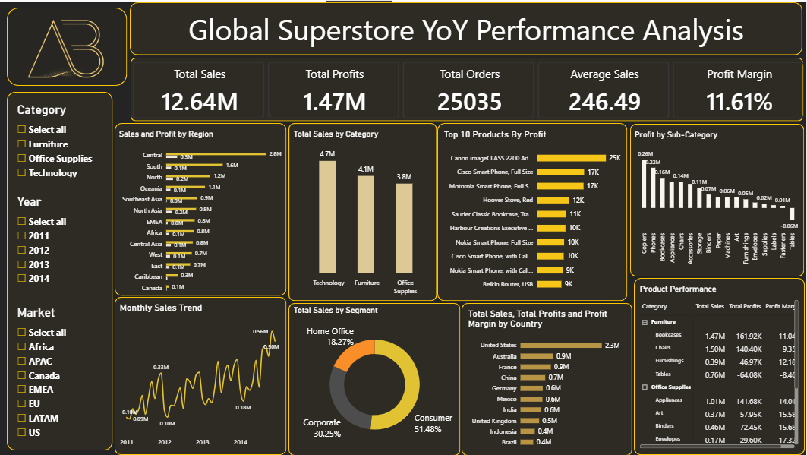
How did I make the dashboard suitable for management?
I put the main KPIs at the top, grouped related charts together and kept the colours and formatting consistent. I also shortened large numbers using millions and thousands so they are easier to read.
The dashboard lets management go from the overall summary down to more detailed product, customer and geographic analysis.

Business Questions
1. What is the overall sales performance of the company?
Global Superstore made total sales of 12.64 million and total profit of about 1.47 million from roughly 25.03 thousand orders.
Average sales per order line were 246.49, and the overall profit margin was 11.61%. The business was profitable overall, but profitability differed across product groups and locations.
2. Which regions generate the highest sales and profit?
Central had the highest sales at about 2.8 million and the highest profit at about 0.3 million.

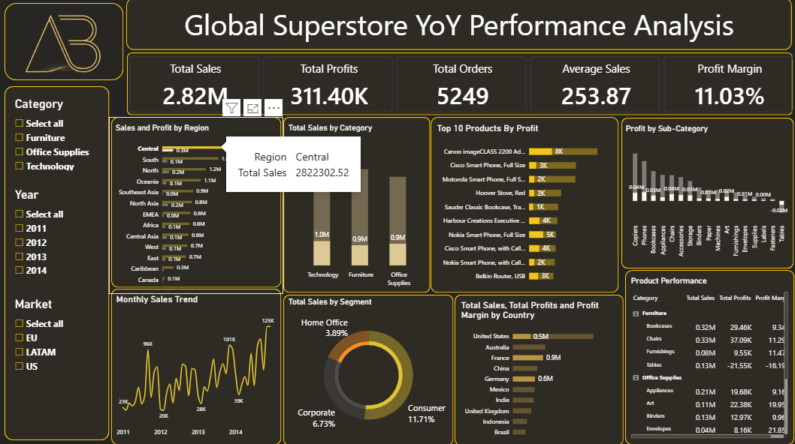
South came second in sales at about 1.6 million. North had about 1.2 million in sales but made more profit than South, which shows that higher sales don't always mean higher profit.
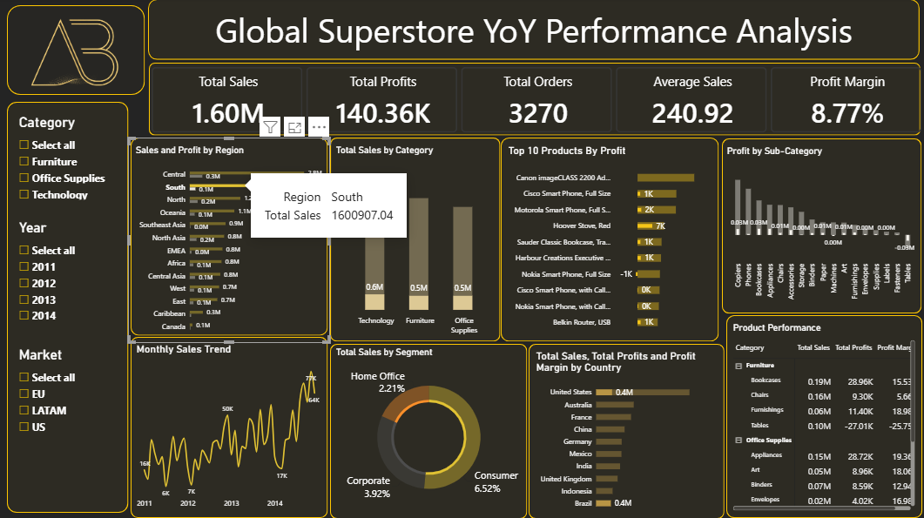

3. Which customer segments contribute the most revenue?
Consumer was the biggest contributor at 51.48% of total sales. Corporate contributed 30.25% and Home Office 18.27%. So Consumer customers brought in slightly more than half of the company's revenue.
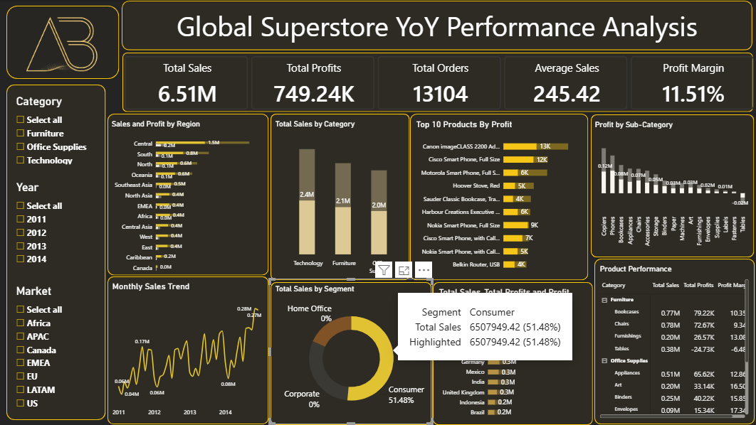
4. Which product categories perform best?
Technology did best overall, with about 4.74 million in sales, 663.78 thousand in profit and a profit margin of 13.99%.
Furniture had about 4.11 million in sales but a lower margin of 6.94%. Office Supplies had about 3.79 million in sales with a margin of 13.69%.
Technology led on both sales and profit, but Office Supplies turned its sales into profit more effectively than Furniture did.
5. Which products are the most profitable?
The Canon imageCLASS 2200 Advanced Copier was the most profitable product, with about 25.20 thousand in profit.
Next were the Cisco Smart Phone, Full Size at about 17.24 thousand and the Motorola Smart Phone, Full Size at about 17.03 thousand. The Hoover Stove, Red and the Sauder Classic Bookcase, Traditional were also among the top profit contributors.
6. What trends can be observed over time?
The monthly sales chart shows an upward trend overall from 2011 to 2014, with higher sales towards the end of the period.
Sales jumped around quite a bit from month to month, with regular peaks and quieter periods. This looks like seasonality, which management could look into further when planning inventory and promotions.

7. What recommendations should management implement?
Management should focus on the profitable product groups, investigate the losses in Tables, review Furniture's weaker margins, keep leading products in stock and use past sales patterns to plan stock levels.

Part 4: Business Insights
Five key business insights
- The business was profitable overall. Sales of 12.64 million produced about 1.47 million in profit, giving a profit margin of 11.61%.
- Technology was the strongest category. It had about 4.74 million in sales and 663.78 thousand in profit, beating the other categories on both.
- Furniture's high sales didn't turn into equally strong profit. It made about 4.11 million in sales, but its 6.94% margin was far below Technology and Office Supplies.
- Consumer customers were the main source of revenue. They made up 51.48% of total sales, compared with 30.25% for Corporate and 18.27% for Home Office.
- Performance varied a lot between product groups. Copiers made about 0.26 million in profit, while Tables recorded a loss of about 64.08 thousand.
Three business risks
- Continued losses from Tables could reduce overall profitability. The sub-category had about 0.76 million in sales but a loss of about 64.08 thousand.
- Furniture's low margin is a profitability risk. With a 6.94% margin, a large share of sales produces fairly little profit, leaving less room to absorb extra costs.
- Monthly sales fluctuations make inventory planning risky. Overstocking in quiet periods could tie up money, while understocking in peak periods could mean missed sales.
Three business opportunities
- Technology offers a chance for profitable growth. Its leading sales, profit and 13.99% margin suggest it is worth looking into expanding the successful products.
- Furniture could improve profit without relying only on more sales. Reviewing the loss-making Tables sub-category could lift the category's overall performance.
- Corporate and Home Office customers could be targeted with sales campaigns. Together they contribute 48.52% of revenue, which is a big customer base alongside Consumer.
Part 5: Business Recommendations
What actionable recommendations should management implement?
- Investigate why Tables are making a loss. Tables lost about 64.08 thousand even though they had substantial sales. I recommend reviewing profitability by product, market and discount level, then checking purchasing and delivery costs before deciding whether to change prices or drop the product.
- Prioritise profitable Technology products. Technology had the highest sales and profit. I recommend keeping its best products in stock and testing focused promotions while watching the profit margin.
- Review Furniture's pricing and cost structure. Furniture's margin was only 6.94%, compared with 13.99% for Technology and 13.69% for Office Supplies. I recommend looking at low-margin products, supplier terms and discount practices to find realistic improvements.
- Plan inventory around monthly demand. The sales trend has regular peaks and quieter periods. I recommend using historical monthly sales by category and market to prepare stock ahead of busier periods and avoid excess stock during slower months.
- Protect the Consumer customer base and test campaigns for other segments. Consumer customers bring in 51.48% of revenue, so service quality and product availability should stay strong for them. At the same time, relevant offers could be tested with Corporate and Home Office customers, and the campaigns should be judged on both sales and profit.
- Compare regional profitability before allocating resources. Central led on sales and profit, while North made more profit than South despite lower sales. I recommend comparing product mix, discounts and margins across regions before spending more on promotions or inventory.
Executive Summary
For this project I built an interactive Power BI dashboard to analyse Global Superstore's sales and profitability from 2011 to 2014. It covers overall performance, geographic contributions, customer segments, product categories and monthly sales trends.
The business made 12.64 million in sales and about 1.47 million in profit, with an overall profit margin of 11.61%. Technology was the strongest category, Central was the top region, and Consumer customers contributed 51.48% of revenue.
The main concern I found was uneven profitability. Furniture had high sales but a lower margin than the other categories, and Tables recorded a loss of about 64.08 thousand.
My recommendations focus on investigating loss-making products, improving Furniture margins, supporting profitable Technology products and planning inventory around demand. The Year, Market and Category filters on the dashboard let management explore these results in more detail.

